# **Robotics Process Automation(RPA) Practical Evaluation**

**Name: Vishwakarma Shivam Suresh Sushila**

**Roll no: 6709**

**Tool name: Open RPA (**[**https://www.openrpa.dk/openrpa**](https://www.openrpa.dk/openrpa)**)**

## **1. Brief about the tool**

Open RPA is an open-source Robotic Process Automation (RPA) platform that allows organizations to automate repetitive business processes without the licensing costs of commercial RPA tools like UiPath or Automation Anywhere.

Open RPA provides a comprehensive automation platform that includes both attended (human-supervised) and unattended (fully automated) bot capabilities. It's designed to democratize process automation by making RPA technology accessible to organizations of all sizes.

**Key Features:**

* **Visual workflow designer** - drag-and-drop interface for building automation workflows
* **Multi-platform support** - works with Windows applications, web browsers, databases, and APIs
* **Scalable architecture** - can handle multiple bots running simultaneously
* **Integration capabilities** - connects with various systems including SAP, Oracle, web services, and Office applications
* **Security features** - includes user management, audit trails, and encrypted communications

**Core Components:**

* **OpenRPA Client** - the main application where users design and run automations
* **OpenFlow** - workflow engine and web-based management portal
* **NodeRED integration** - for creating complex automation flows
* **Robot framework** - for executing the automated processes

**Common Use Cases:**

* Data entry and migration
* Report generation
* Invoice processing
* Customer service automation
* System integration tasks
* Compliance and audit processes

**Benefits:**

* Cost-effective alternative to commercial RPA solutions
* Active open-source community support
* Customizable to specific business needs
* No vendor lock-in
* Transparent development process

## **2. Installation steps**

1. Go to OpenRPA website and click on Download button and MSI Installer will be downloaded.

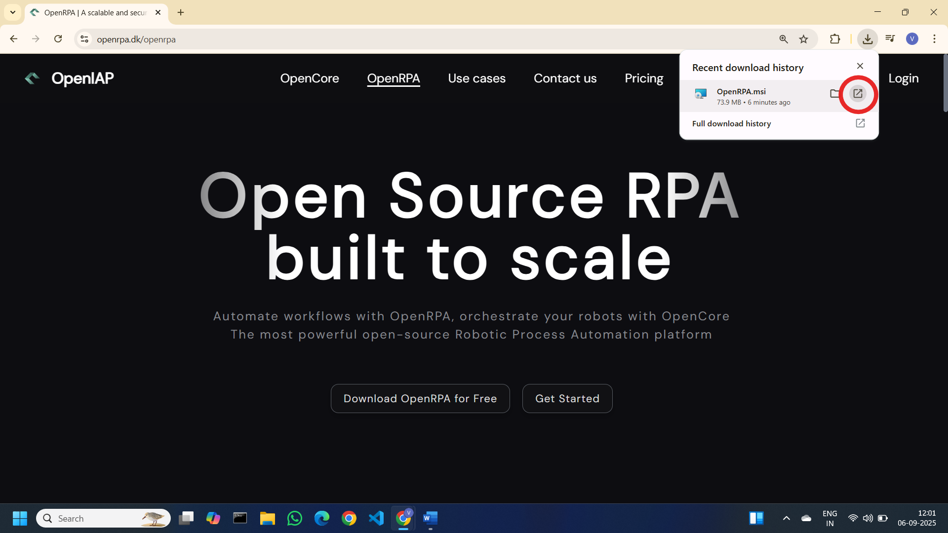

2. Run the MSI Installer

Click on “Next” Button

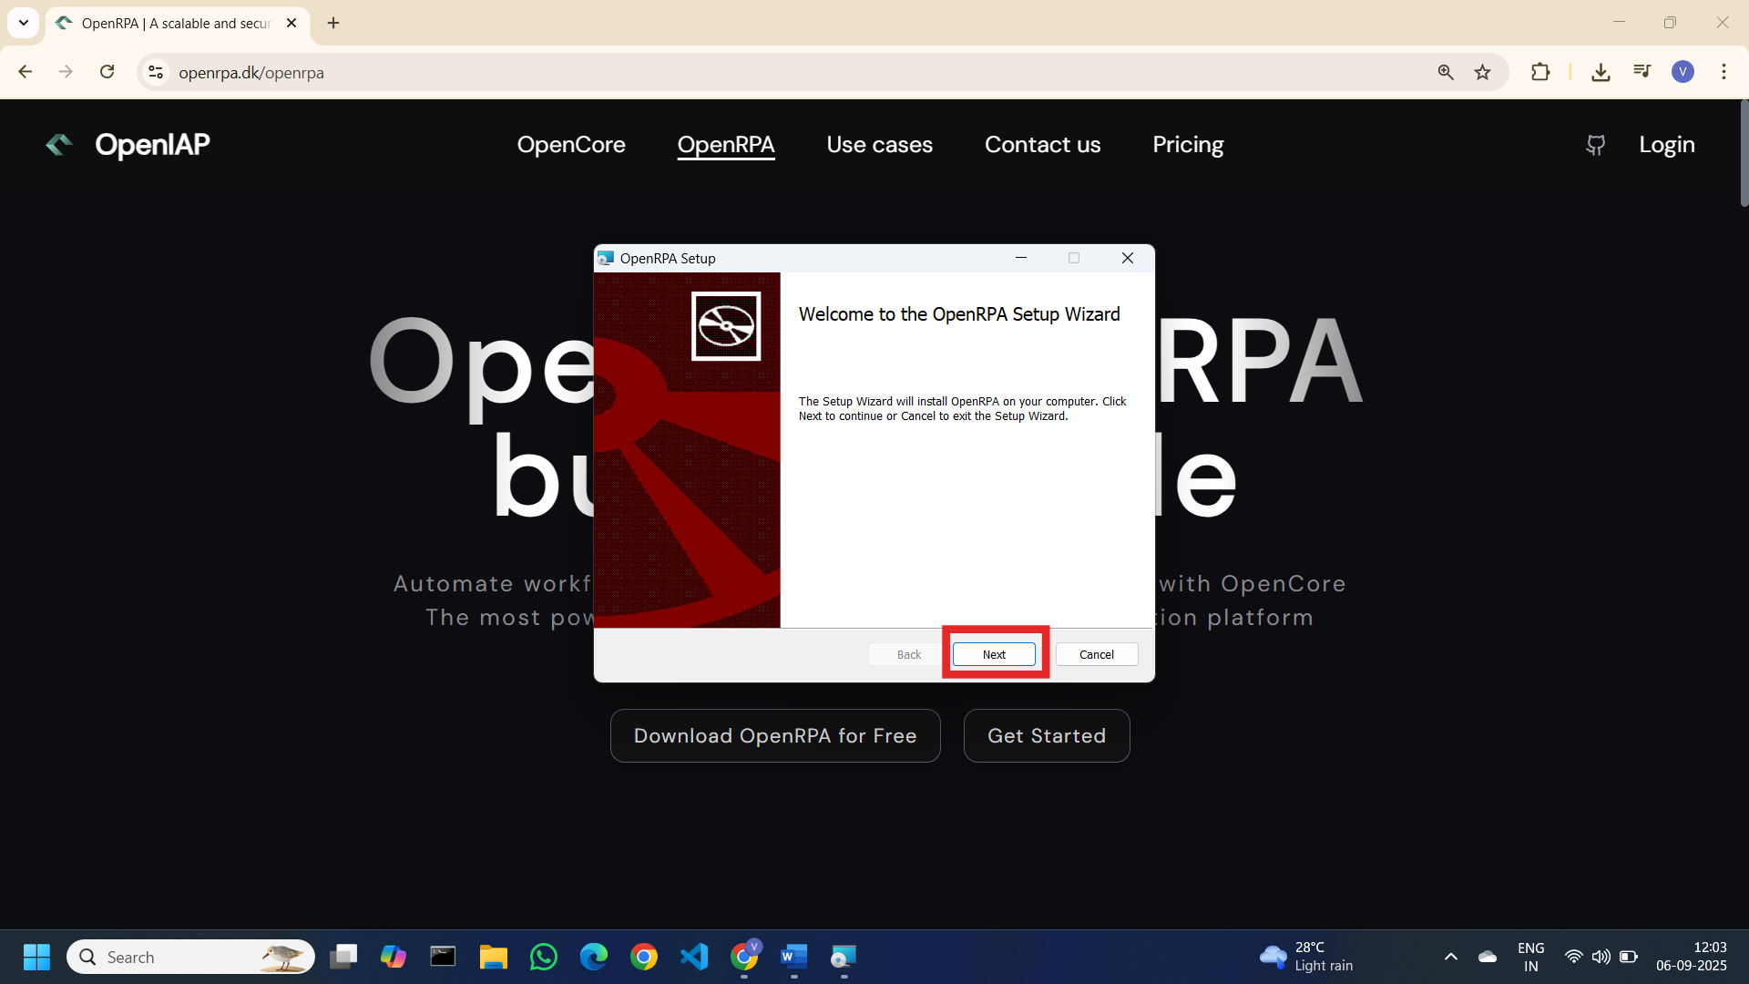

Select the Scope as per your preference and click on “Next” Button

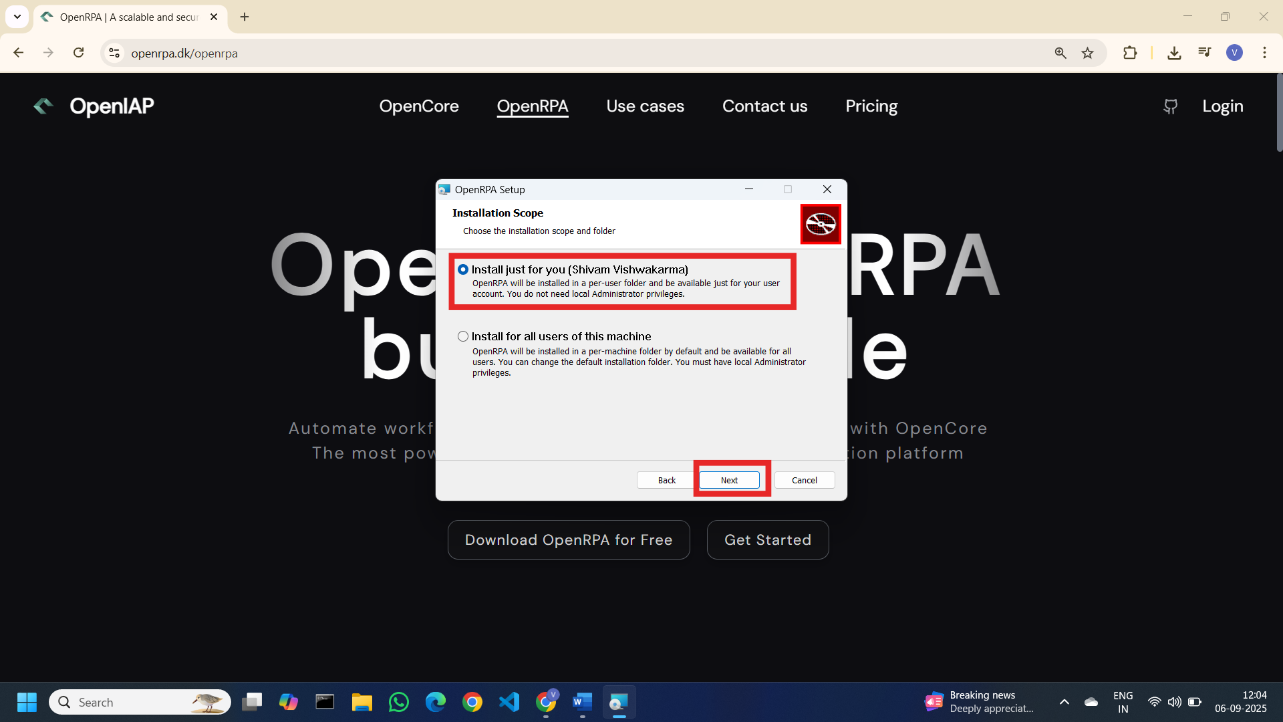

Select the Installation path as per preference and click on “Next” Button

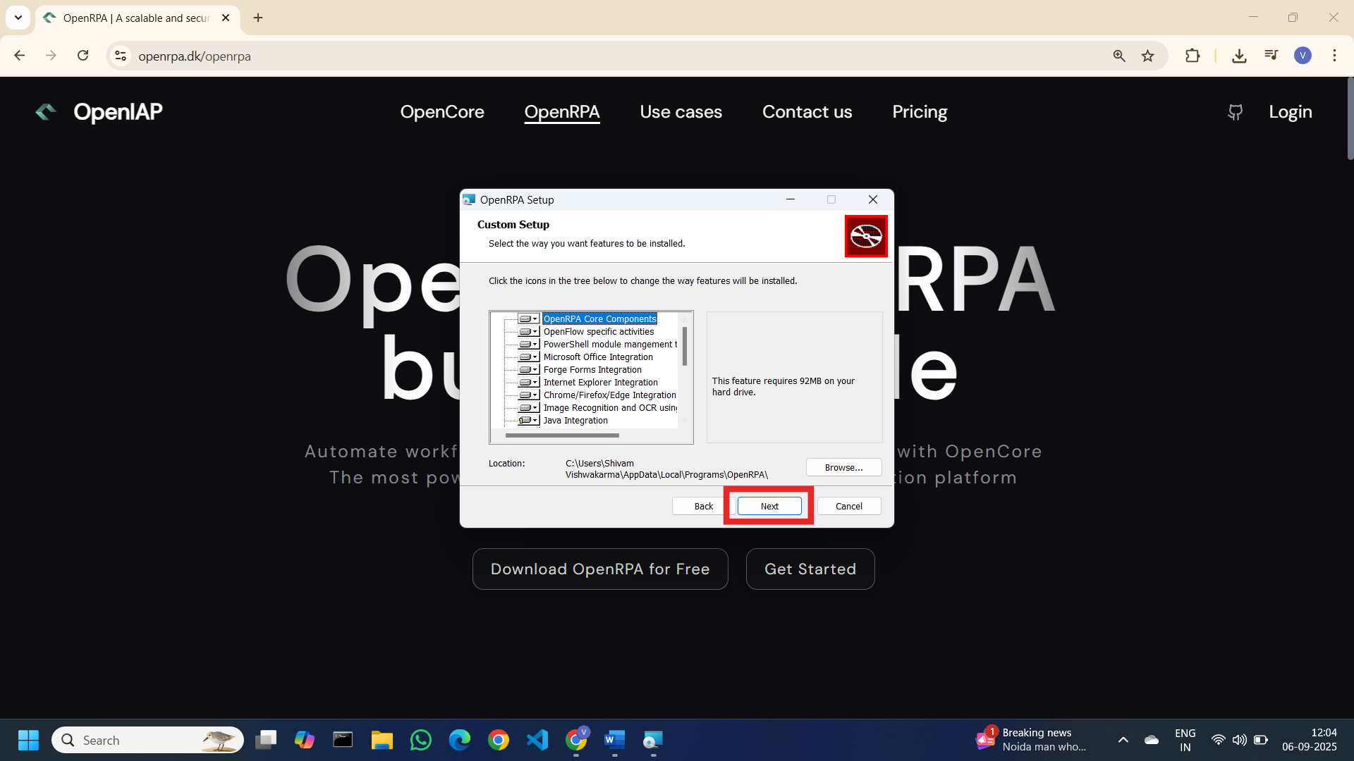

click on “Install” Button

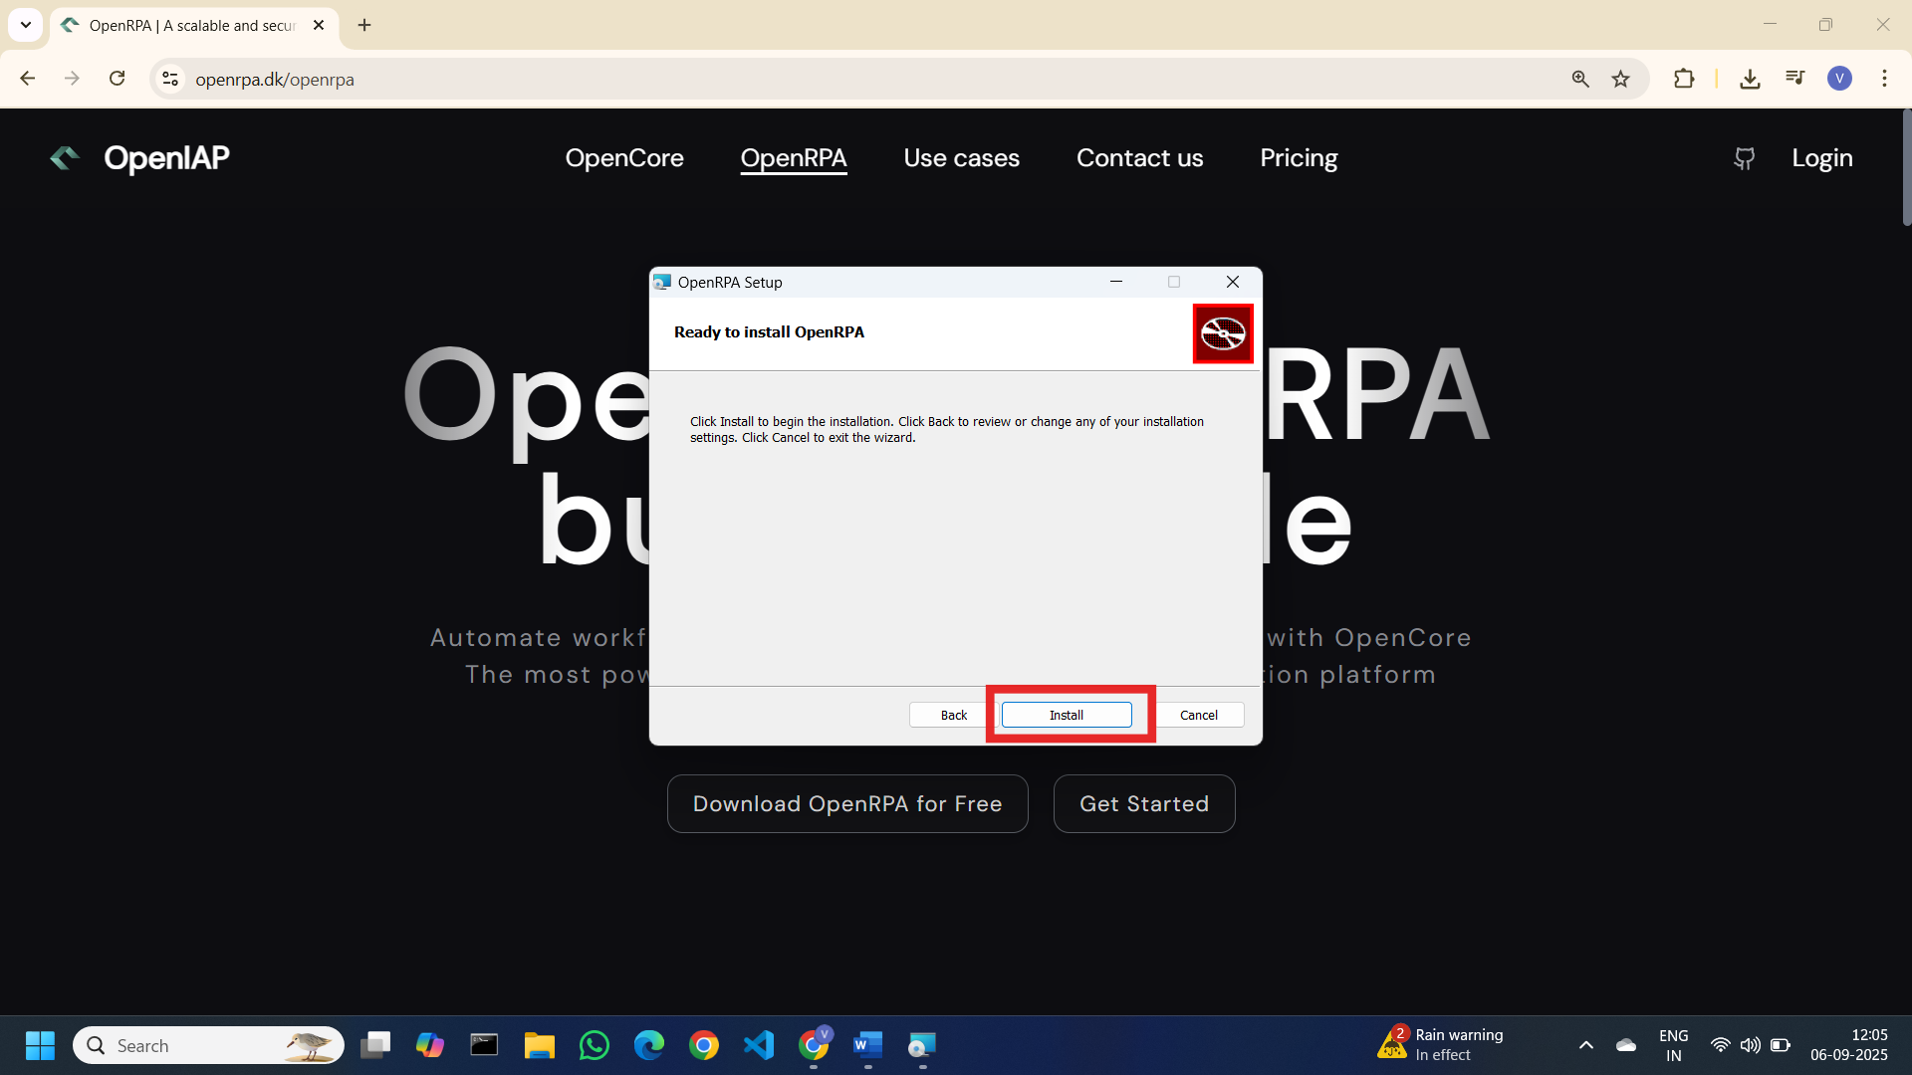

Installation will be started after execution completed click on “Finish” Button

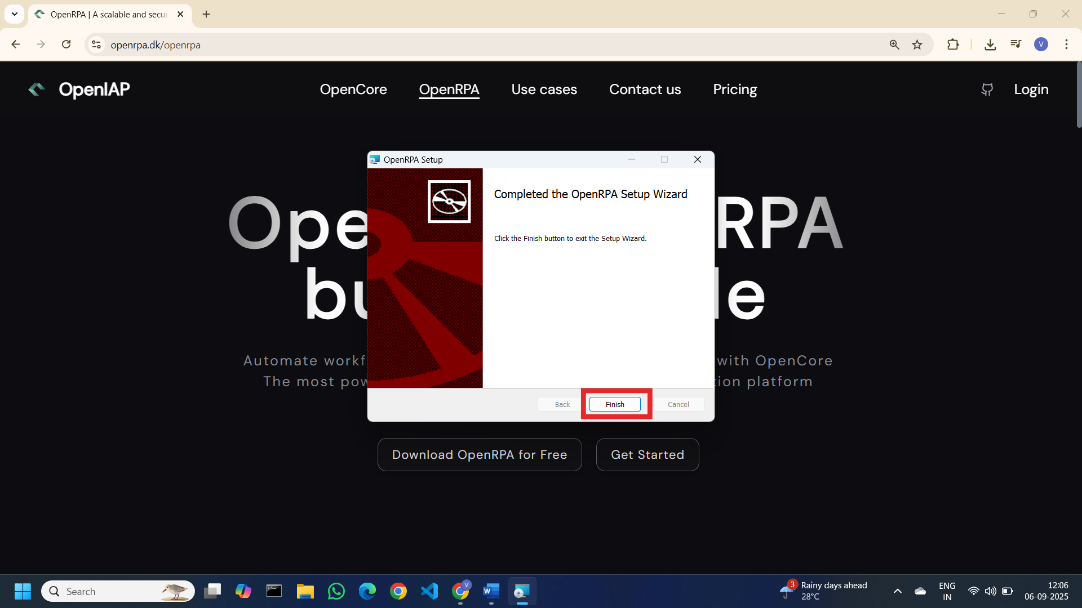

OpenRPA is successfully install in our device but before creating project we need to have and OpenRPA Account and a workspace to start with workflows.

Search for “OpenRPA” on windows search and open it.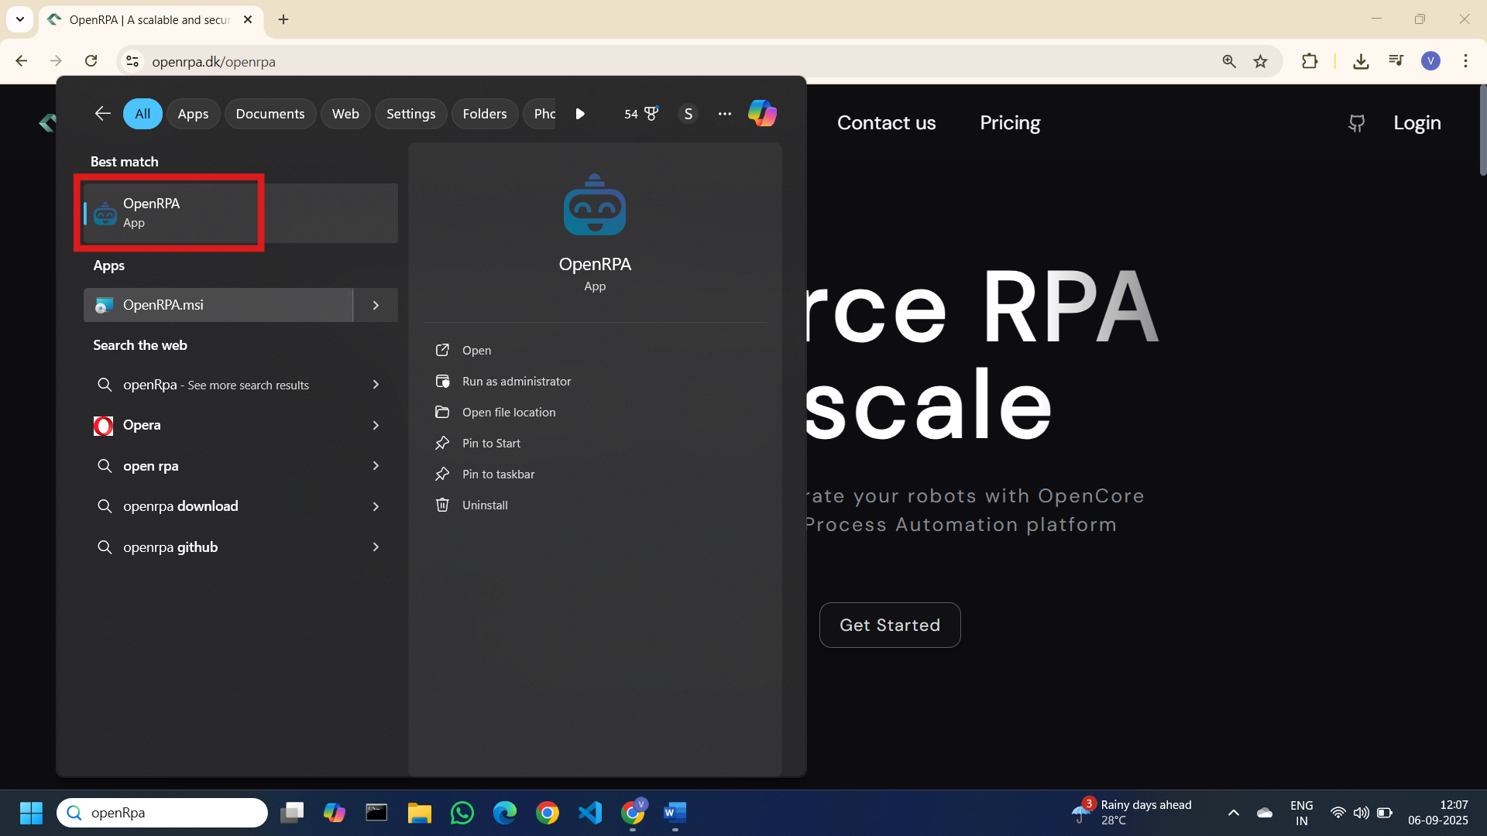

And pop up will show and navigate you to OpenRPA login page. Create or login to account

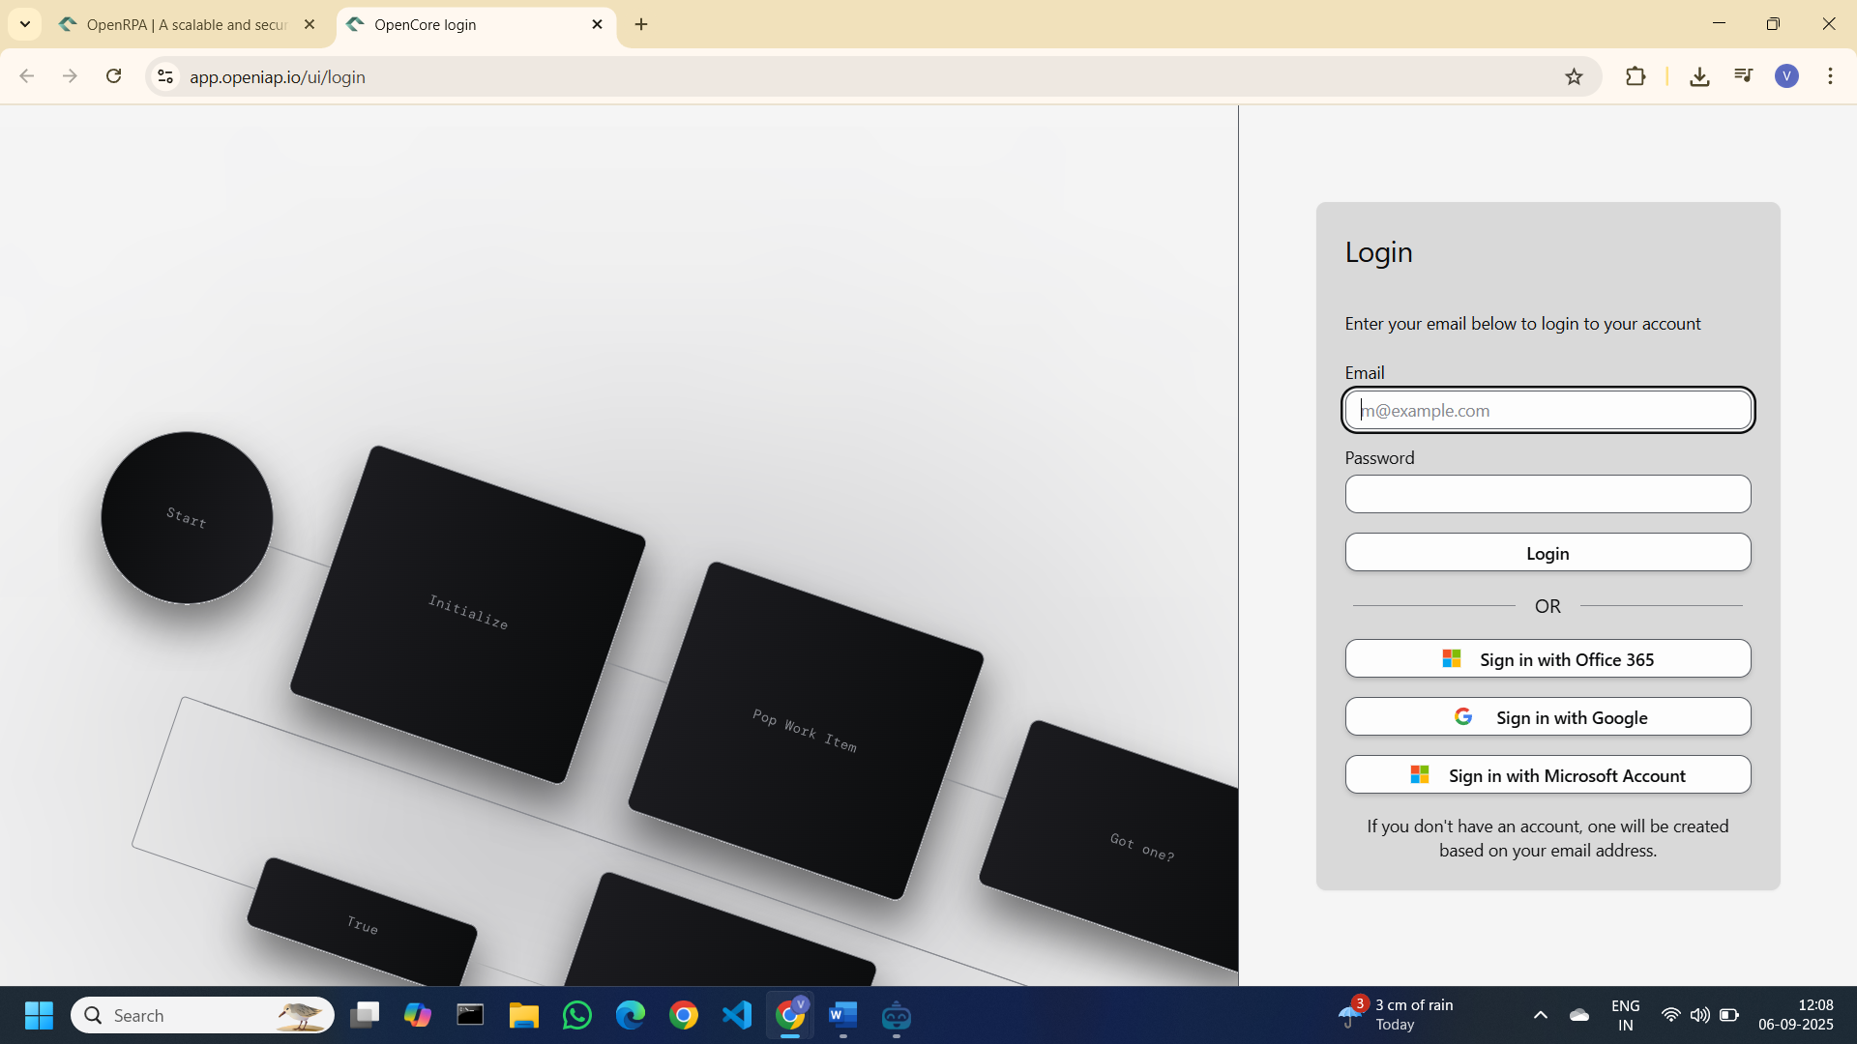

After login Dashboard screen will appear. Click on profile icon

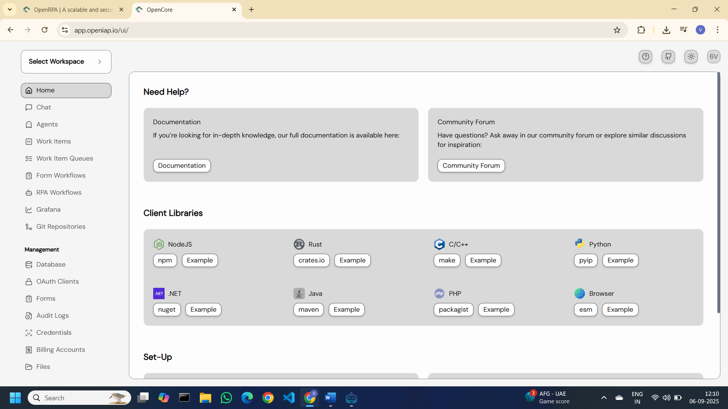

It will ask to create the Workspace. Give a name of workspace

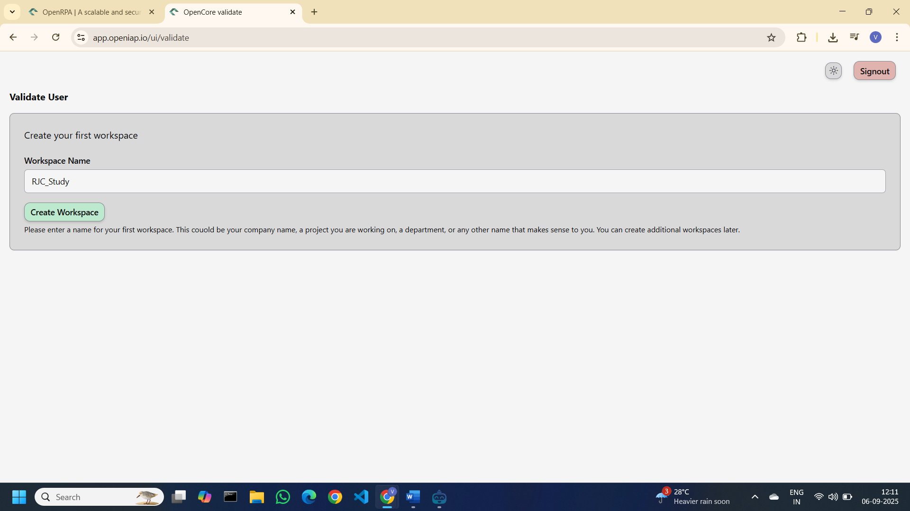

As per image below Workspace is successfully created and showing on dashboard.

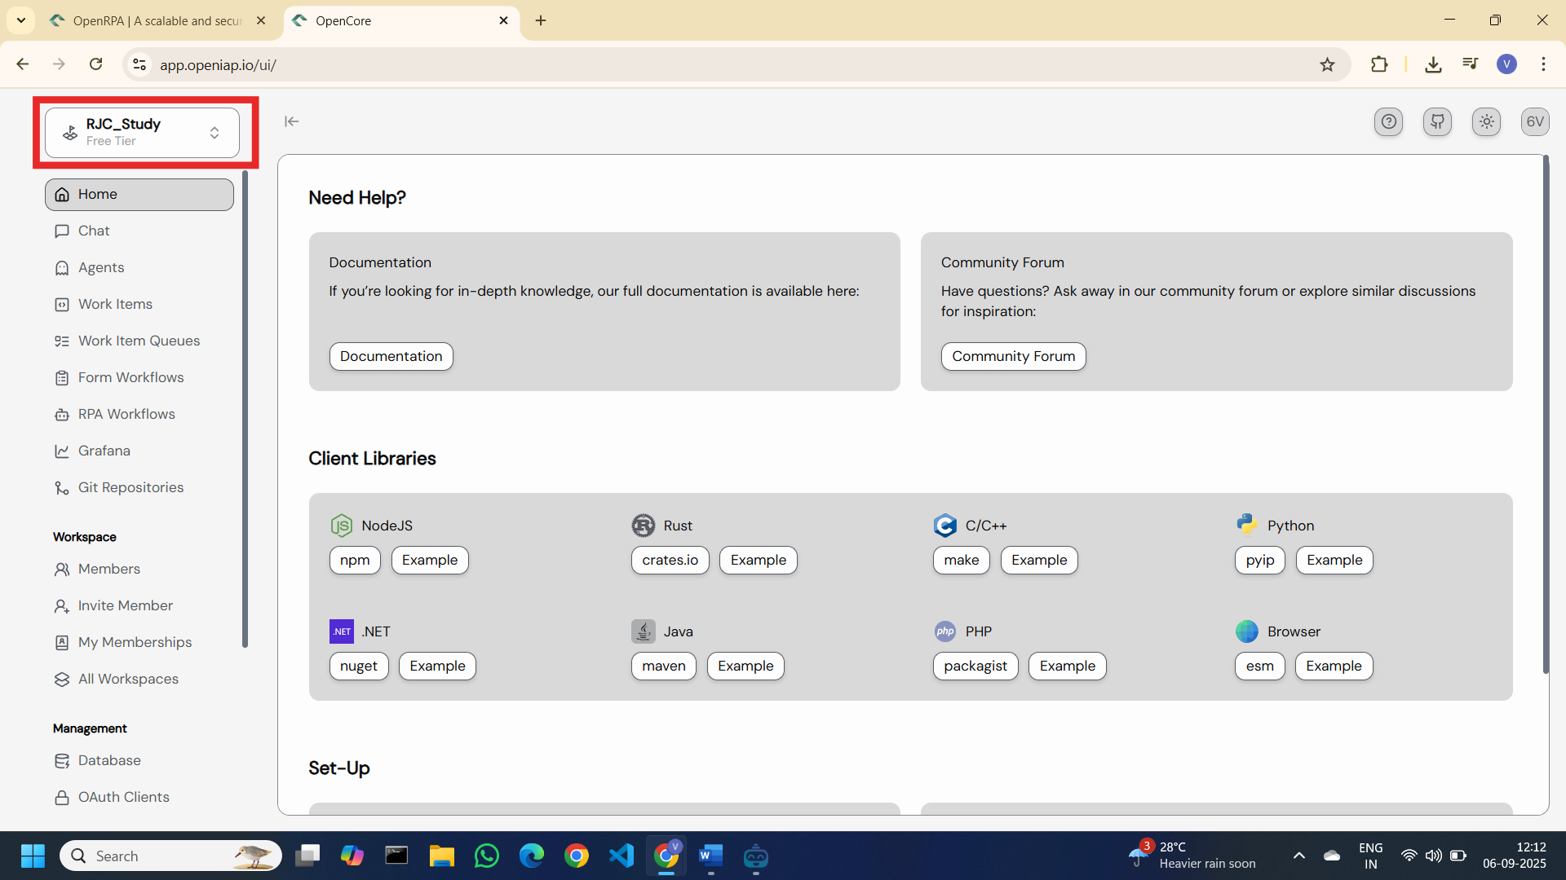

We are good to go now. Run the OpenRPA application again

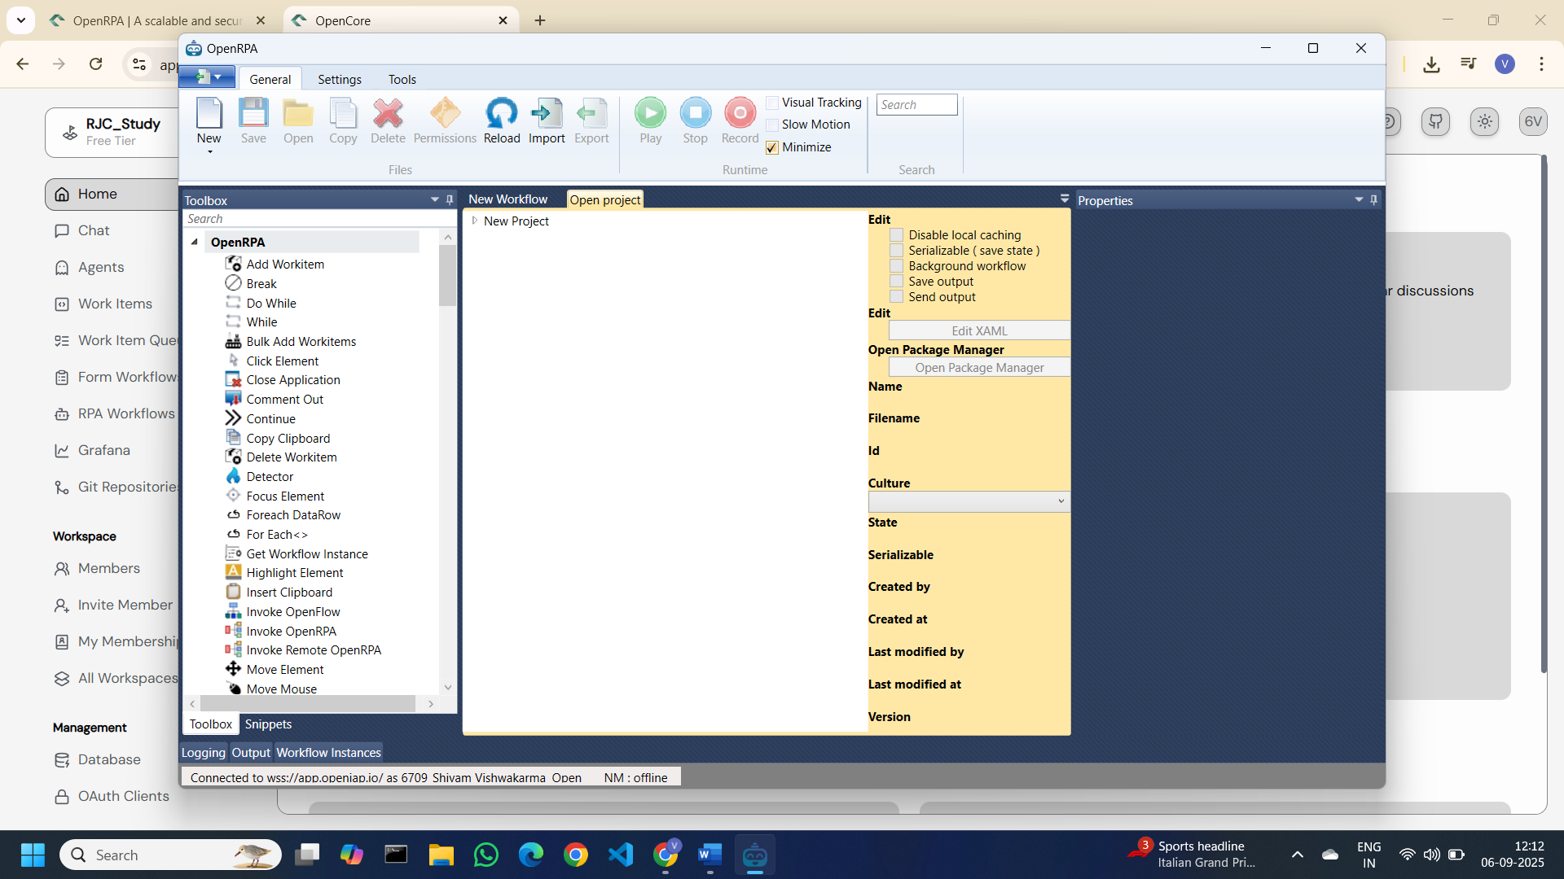

## **3. Perform task using the tool**

Start OpenRPA, Go to New 🡪 New Project

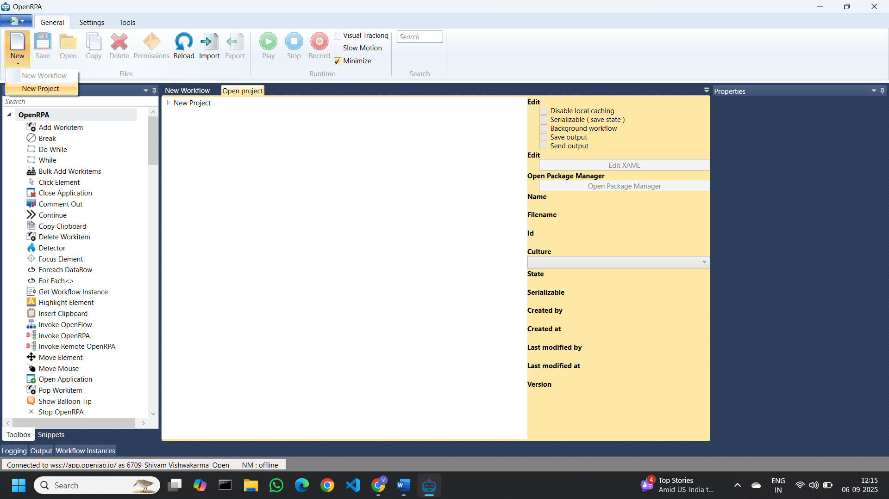

Name the project

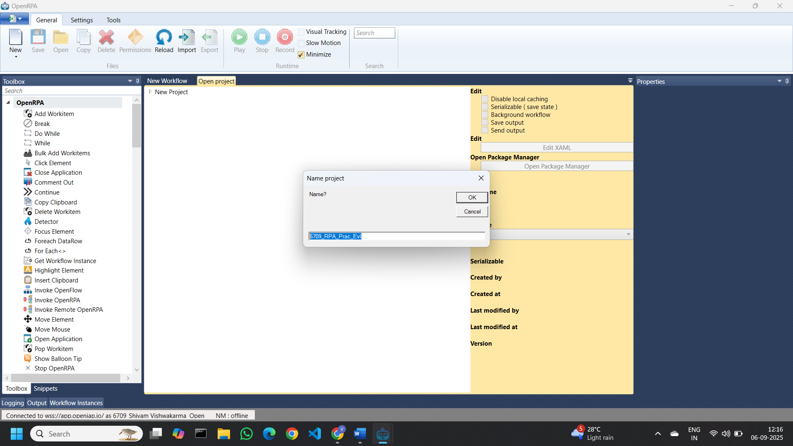

Project created. Click on “New Workflow”

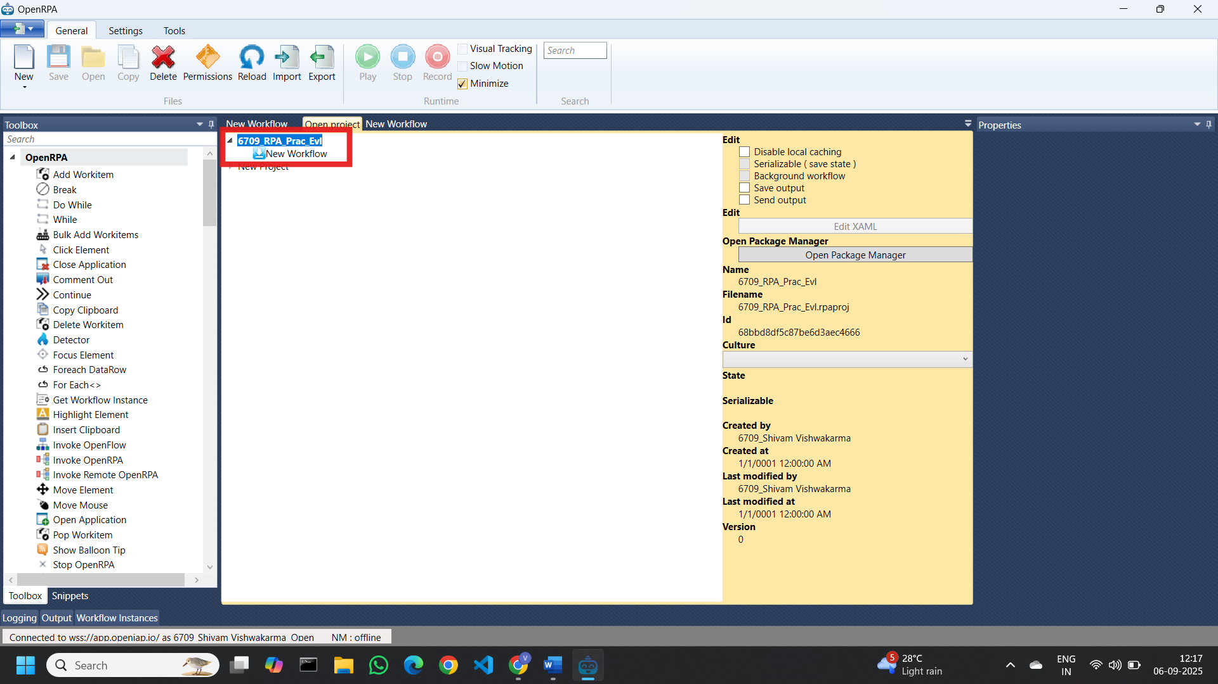

New Workflow screen. By default we get “sequence”

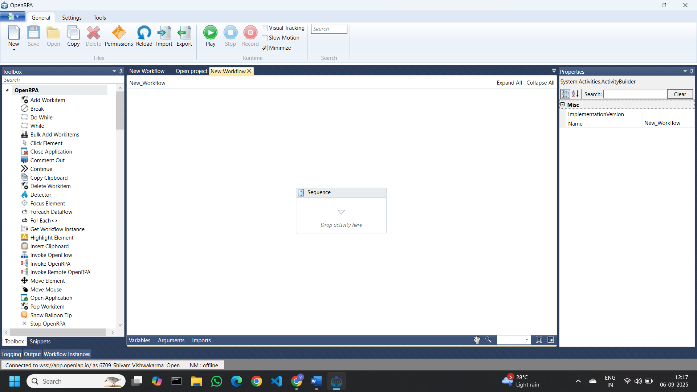

Go to Variables option and create 2 variables as below

|  |  |  |  |  |
| --- | --- | --- | --- | --- |
| Sr No. | Variable name | Data Type | Scope | Default Value |
| 1 | Number | Double | Sequence (by Default) | 5 (Any whole number greater than 0) |
| 2 | iterater | Double | Sequence | 1 |

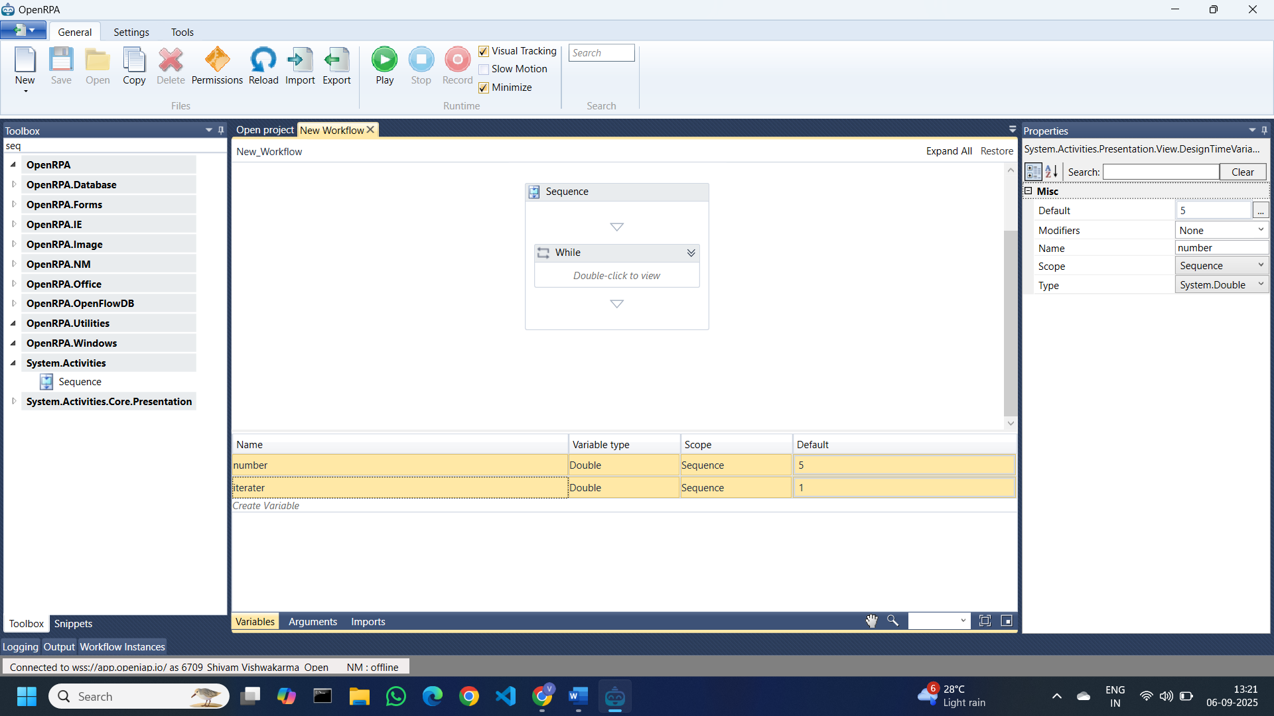

Add “While” activity from Toolbox and give condition: ***iterater <= 10***

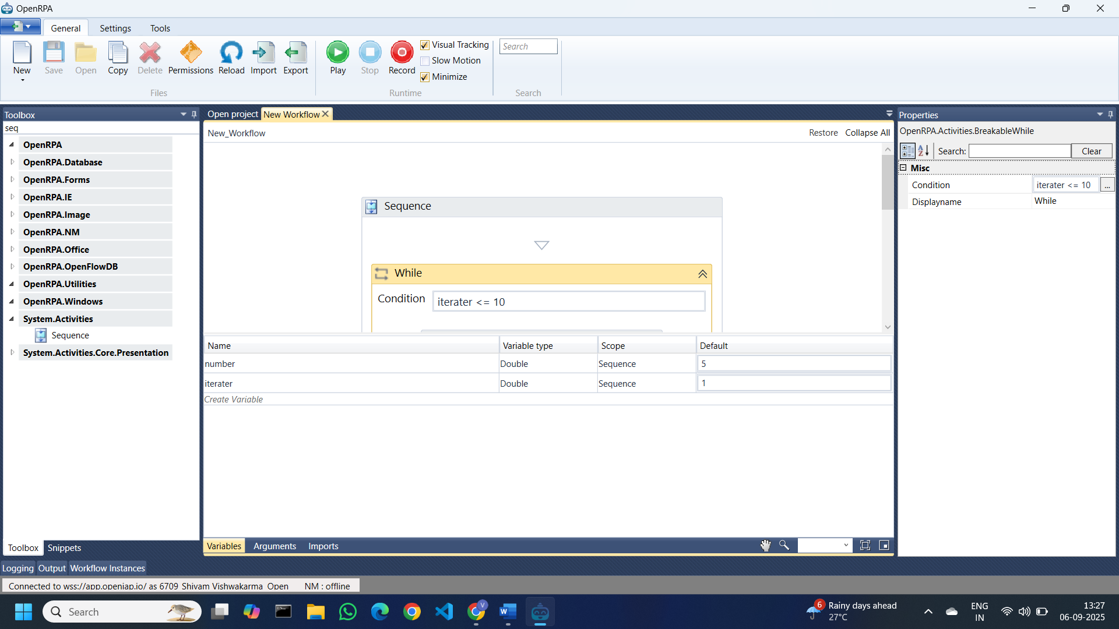

Inside “while” add “WriteLine” & “Assign” activity from toolbox and place as per below image

Expression for “while”: ***(number*iterater).ToString***

Expression for “Assign”: ***iterater = iterater+1***

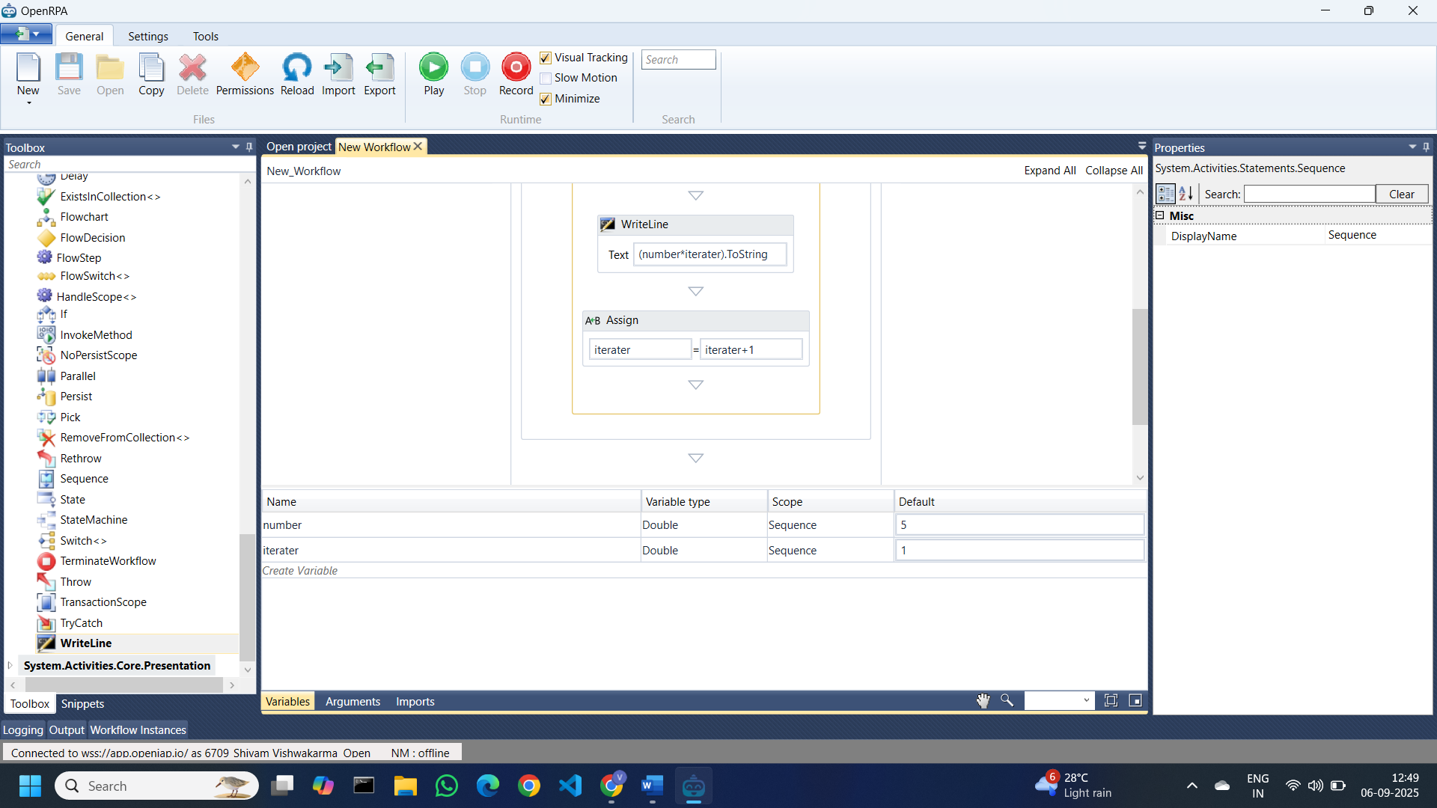

Final Workflow

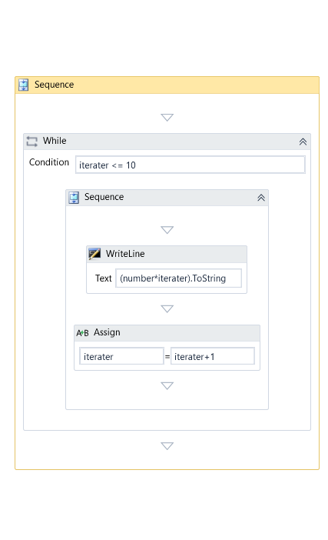

Run the Workflow and you will gettable of the number variable (5)

